**Paper Title* (use style: paper title)**

**Do not exceed two lines**

1st Author Given Name Surname[1],*, 2nd Author Given Name Surname[2],†   
1 Department, Faculty, University, City, Country

2 Department, Faculty, University, City, Country

*Abstract*. This document is a template and already defines the components of your abstract in its style sheet. The abstract should state briefly (200 words) the purpose of the research, the problem and experimental approach, the principal results and major conclusions. References should be avoided through the abstract.

*\*CRITICAL: Do Not Use Symbols, Special Characters, Footnotes, or Math in Paper Title or Abstract*.

Keywords: Component, Formatting, Style, Styling, Insert (3 to 5 key words).

# Introduction

This template has been prepared for ‎the 2nd International and 4th National Conference on Biomathematics, February 8-10, 2023, at the University of Mazandaran, Babolsar, Iran. ‎The template‎ ‎provides authors with most of the formatting specifications needed to prepare electronic versions of their papers in 6 pages‎. ‎Some components‎, ‎such as multi-leveled equations‎, ‎graphics‎, ‎and tables, are not prescribed‎, ‎although the various table text styles are provided‎. ‎The formatter will need to create these components‎, ‎incorporating the applicable criteria that follow‎.

Also‎, ‎pay attention to the following points‎:

* ‎The article should include abstract‎, ‎introduction‎, ‎main results‎, ‎conclusion and references, and should be structured in maximum 6 pages according to the specified format‎.
* ‎Use a half-quote for two-part words‎.
* ‎The name of the file with the extension‎ .‎docx must be the first letter of the speaker's name along with the last name‎. ‎If the speaker has more than one presentation‎, ‎use the number to distinguish the articles‎. ‎For example‎, ‎if the speaker is Z-Azimi and presents two articles‎, ‎the name of the second article should be Z-Azimi2.docx‎. ‎To send the article‎, ‎you must save all its files in the form of a compressed folder and upload the‎ *.‎zip* or‎ *.‎rar* file through the conference site to the address http://conf.umz.ac.ir/biomath/fa/‎. ‎Also‎, ‎the generated PDF file should be sent through this site‎.
* Each participant's name may appear as one of the authors in a maximum of three submitted articles‎.
* ‎An additional fee will be charged for the submission of the second and third articles.
* **Important:** Submissions that do not follow the guidelines, will be rejected without review.
* It is important to note that authors are responsible for spelling errors and ungrammaticality.

# Prepare Your Paper Before Formatting

Before you begin to format your paper, first write the content and save it as a separate text file. Complete all content and organizational editing before formatting. However, an excellent style manual for academic writers is [7] or authors may simply use this template to write their papers.

## Abbreviations and Acronyms

Define abbreviations and acronyms when they are first used in the text, even if they have already been defined in the abstract. Abbreviations such as SI, MKS, and CGS do not need to be defined. Do not use abbreviations in the title or headings unless they are unavoidable.

## Units

* Use either SI (MKS) or CGS as primary units (SI units are recommended). English units may be used as secondary units (in parentheses). An exception would be the use of English units as identifiers in trade, such as “3.5-inch disk drive”.
* Avoid combining SI and CGS units, such as current in amperes and magnetic field in oersteds. This often leads to confusion because equations do not balance dimensionally. If you must use mixed units, clearly state the units for each quantity that you use in an equation.
* Do not mix complete spellings and abbreviations of units: “Wb/m2” or “webers per square meter”, not “webers/m2”. Spell out units when they appear in text: “ a few henries”, not “ a few H”.
* Use a zero before decimal points: “0.25”, not “.25”. Use “cm3”, not “cc”. (*bullet list*)

## Equations

The equations are an exception to the prescribed specifications of this template. You will need to determine whether or not your equation should be typed using either Times New Roman or Symbol font (no other font, please). To create multileveled equations, it may be necessary to treat the equation as a graphic and insert it into the text after your paper is styled.

Number equations consecutively and independent of the sections’ number. Authors should use a table with hidden borders to show equations. Place the equation and its number, as in (1), in left and right columns, respectively. To make your equations more compact, you may use the solidus ( / ), the exp function, or appropriate exponents. Italicize Roman symbols for quantities and variables, but not Greek symbols. Use a long dash instead of a hyphen for a minus sign. Punctuate equations with commas or periods when they are part of a sentence. as in:

|  |  |
| --- | --- |
| (1) | $$a+b=c.$$ |
| (2) | $$\frac{∂^{2}}{∂x^{2}}u-\frac{∂^{2}}{∂y^{2}}u=\frac{1}{r}∇^{2}ω\left(\int_{0}^{T}{\frac{\dot{θ}}{\sin\left(π-2τ\right)}}\right)dt+e^{-iωt}.$$ |
| (3) | $∆C≈\frac{∂C}{∂V_{1}}∆V_{1}+\frac{∂C}{∂V_{2}}∆V_{2}.$ |
| (4) |  |
| (5) | $∇C≡{\left(\frac{∂C}{∂V_{1}}.\frac{∂C}{∂V_{2}}\right)}^{T}.$ |

Be sure that the symbols in your equation have been defined before or immediately following the equation. Use “(1)”, not “Eq. (1)” or “equation (1)”, except at the beginning of a sentence: “Equation (1) is . . .” Variables have to be written in Latin and in the italic form.

# Using the Template

The template is used to format your paper and lay out the text. All margins, column widths, line spacing, and text fonts are given; please do not alter them. You can pay attention to special features. For example, the head margin in this template is proportionally larger than usual. This measurement and others are deliberate, using specifications that anticipate your paper as one part of the entire proceedings, and not as an independent document. Please do not change any of the current designations.

After the text editing is complete, the paper is ready for the template. Duplicate the template file using the "Save As" command and use the naming convention prescribed by your conference for the name of your paper. In this newly created file, highlight all the content and import your prepared text file. Now you are ready to format your paper. To do this, use the scrolling down window on the left side of the MS Word Formatting toolbar.

## Authors and Affiliations

**The template is designed for, but not limited to, 2 authors.** The provided author sequence will be used in future citations and by indexing services. Names should not be listed in columns nor group by affiliation. Please keep your affiliations as succinct as possible (for example, do not differentiate among departments of the same organization. It is adequate to address your faculty).

### For papers with more than 2 authors: Add author names horizontally, moving to a third row if needed for more than 8 authors.

### For papers with less than 2 authors: To change the default, adjust the template as follows.

#### Selection: Highlight all author and affiliation lines.

#### Change number of columns: Select the Columns icon from the MS Word Standard toolbar and then select the correct number of columns from the selection palette.

#### Deletion: Delete the author and affiliation lines for the extra authors.

## Identify the Headings

Headings, or heads, are organizational devices that guide the reader through your paper. There are two types: component heads and text heads.

Component heads identify the different components of your paper and are not topically subordinate to each other. Examples include Acknowledgments and References and, for these, the correct style to use is “Heading 5”. Use “figure caption” for your Figure captions, and “table head” for your table titles. Run-in heads, such as “Abstract”, will require you to apply a style (in this case, italics) in addition to the style provided by the drop down menu to differentiate the head from the text.

Text heads organize the topics on a relational, hierarchical basis. For example, the title of the paper is the main heading because all subsequent material relates and elaborates on this one topic. If there are two or more subtopics, the next level head (large Roman numerals) should be used and, conversely, if there are not at least two subtopics, then no subheads should be introduced. Styles named “Heading 1”, “Heading 2”, “Heading 3”, and “Heading 4” are prescribed.

## Main Results

You will be able to generate different types of mathematical environments such as theorems‎, propositions‎, ‎lemmas‎, ‎definitions‎, ‎etc. ‎Consider the following‎:

Theorem 3.1. ‎*State the case‎.*

***Proof.*** ‎For more information to [1], [2] be referred.

**Lemma 3.1.** ‎*This environment is related to a lemma‎.*

**Proposition 3.1.** ‎*This environment is related to a proposition‎.*

***Proof.*** Refer to [4].

‎Proposition‎ 3.1 leads to the following result‎.

**Corollary 3.1.** ‎*This environment is related to a corollary.*

‎The proposed algorithm is expressed as follows‎.

**Algorithm 3.1.** ‎*This environment is related to an algorithm‎.*

## Figures, Tables, and Graphs

#### Image File Formats: The acceptable file format for graphic images is TIF. For scanned images, the formats to be used are TIF or TIFF, EPS and JPEG.

#### Image Resolution: The recommended resolution for photographs (raster images) and line art (charts or images that contain typographic elements) is 300 dpi (dots per inch).

#### Positioning Figures and Tables: Place figures and tables at the top and bottom of columns. Avoid placing them in the middle of columns. Large figures and tables may span across both columns. Figure captions should appear below figures; table headers should appear above tables. Insert figures and tables after they are cited in the text. Use the abbreviation “Fig. 1”, even at the beginning of a sentence.

**Tabele 1. Table type styles**

| Table Head | Table Column Head | | |
| --- | --- | --- | --- |
| Table column subhead | Subhead | Subhead |
| copy | More table copya |  |  |
| 1. Sample of a Table footnote. (*Table footnote*) | | | |

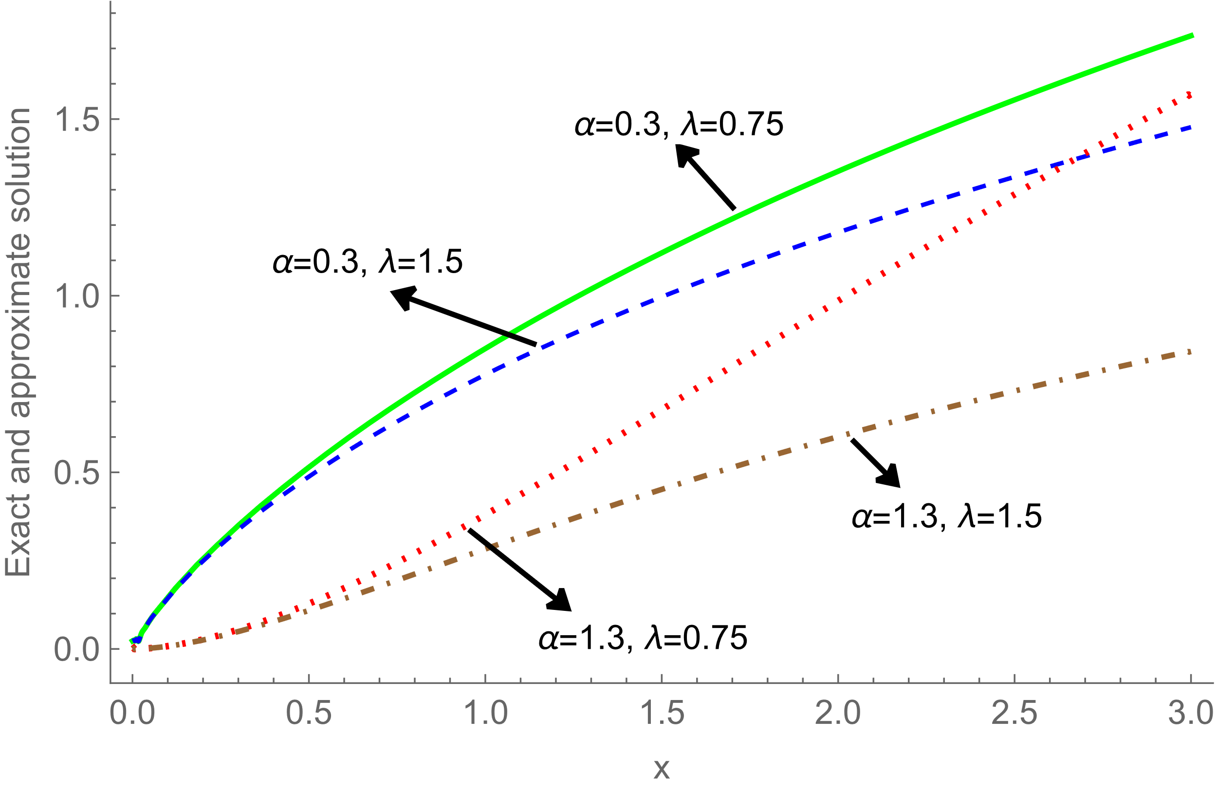

1. **Example of a figure caption.**

Figure Labels: Use 8 point Times New Roman for Figure labels. Use words rather than symbols or abbreviations when writing Figure axis labels to avoid confusing the reader. As an example, write the quantity “Population”, or “ Population, P”, not just “P”. If including units in the label, put them in parentheses. Do not label axes with units only. In the example, write “Magnetization (A/m)” or “Magnetization {A[m(1)]}”, not just “A/m”. Do not label the axes with a ratio of magnitudes and units. For example, write “Temperature (K)”, not “Temperature/K”.

## Footnotes

Footnotes[3] (Times New Roman font 8) are listed at the bottom of the page on which a citation is made. Footnotes are numbered simply and consecutively, regardless of section numbering.

## References

Please ensure that every reference cited in the text is also included in the reference list (and vice versa). Use at most 8 references in APA style.

Simply refer to the reference number, as in [3] - do not use "Ref. [3]" or "reference [3]" except at the beginning of a sentence: "Reference [3] was the first ...".

Number footnotes separately in superscripts. Place the actual footnote at the bottom of the column in which it was cited. Do not put footnotes in the abstract or bibliography. Use letters for table footnotes.

Unless there are six authors or more give all authors’ names; do not use “et al.”. Papers that have not been published, even if they have been submitted for publication, should be cited as “unpublished” [4]. Papers that have been accepted for publication should be cited as “in press” [5]. Capitalize only the first word in a paper title, except for proper names and element symbols.

For papers published in translation journals, please give the English citation first, followed by the original foreign-language citation [6].

# Conclusion

Describe in one paragraph (with a maximum of six lines) the main conclusion and final remarks of the article‎.

##### **References**

1. Eason, G., Noble, B., & Sneddon, I. N. (1955). On certain integrals of Lipschitz-Hankel type involving products of Bessel functions. *Philosophical Transactions of the Royal Society of London. Series A, Mathematical and Physical Sciences*, *247*(935), 529-551.
2. Maxwell, J. C. (1892). A treatise on electricity and magnetism (Vol. 2). Clarendon press.
3. Jacobs, I. S. (1963). Fine particles, thin films and exchange anisotropy. Magnetism, 271-350.
4. Elissa, K., Title of paper if known,” unpublished.
5. Nicole, R., Title of paper with only first word capitalized, *J. Name Stand. Abbrev*., in press.
6. Yorozu, T., Hirano, M., Oka, K., & Tagawa, Y. (1987). Electron spectroscopy studies on magneto-optical media and plastic substrate interface. *IEEE translation journal on magnetics in Japan*, 2(8), 740-741.
7. Young, M. (2002). *Technical writer's handbook.* University Science Books.

1. * Corresponding author. E-mail address: name@uni.ac.ir
2. † Speaker. E-mail address: name@uni.ac.ir
3. Footnote (Please capitalize the first letter of the first word)